ARINC 653

Federated Architecture

* Each module hosts a single application specifically for certain function
* The high amount of redundant hardware, cables and high-power consumption.
* Each module has its own processing unit, memory and peripherals.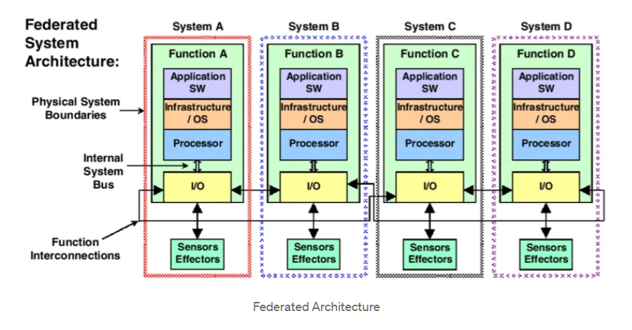

Integrated Modular Avionics – IMA

* Provides a higher integration between programs used for controlling aircraft equipment
* distributed, flexible and reusable architecture
* the IMA architecture uses an operating system to manage the execution of applications running in a same IMA module.
* run in the same equipment, sharing resources, and reducing the time used for communications between the applications
* With IMA, hardware can be bought alone and software can be developed according to the requirements, upgrade of both hardware and software can happen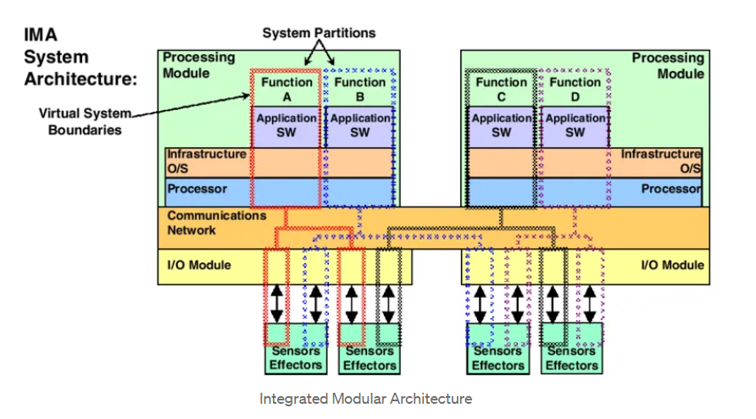 independently from each other, reducing costs of maintenance
* Partitioning: spatial (separate memory), temporal (dedicated time interval for each partition)
* APEX (Application executive): and application programming interface to allow the IMA applications to run simultaneously in the same module
* Partitions and processes
* Health monitor: able to provide the correct recovery action for errors and failures detected during the IMA module execution
* Configuration file: partition names, scheduling orders, errors and recovery actions (health monitors)